

**Medi-Caps University, Indore**

**Report of Expert Lecture/Workshop/Symposium/Conference/Industry Visit/Meeting**

**Name of Expert Lecture/Workshop/Symposium/Conference/Industry Visit/Meeting:**

COMPREHENDING THE CLOUD

**Organizing department :** MUACM

**Date of the event:** 15th August 2021

**Time:** 11:00 AM – 12:00 PM

**Venue:** **Zoom Meetings**

**Number of attendees:** 54

**Objectives:**

To give the insight of cloud computing to the students or participants .

**Expert(s) Profile:**

**Dr. Amol Goje** was the speaker for the event. Dr. Goje is the Founder of Cognier Academy. He is a prominent speaker and a cloud enthusiast. He is a premier innovator, who has implemented over 13 e-health diagnostics.

**About the Expert Lecture/Workshop/Symposium/Conference/Industry Visit/Meeting: (summary of the event in 200 words)**

Presenters/Coordinators**:** Dr. Amol Goje/Suchismita Nanda and Raj Soni

On the 15th of August 2021, Comprehending the Cloud, a session on cloud computing was organized by MUACM on the Zoom Meetings Platform.The event was held on our Nation’s Independence Day. We received over 200 registrations, out of which around 50 attended the event. The event started at 11:00 AM and ended with an interactive discussion on cloud tech at 12:00 PM.

A webinar on Cloud Computing and its technological and economic effects on the world. The webinar discussed container-less and service-less computing, compute services, cloud security and storage services.

The event covered cloud topics like container-less and service-less computing, compute services (AWS, Azure), cloud security and storage services.:

**Photographs:**

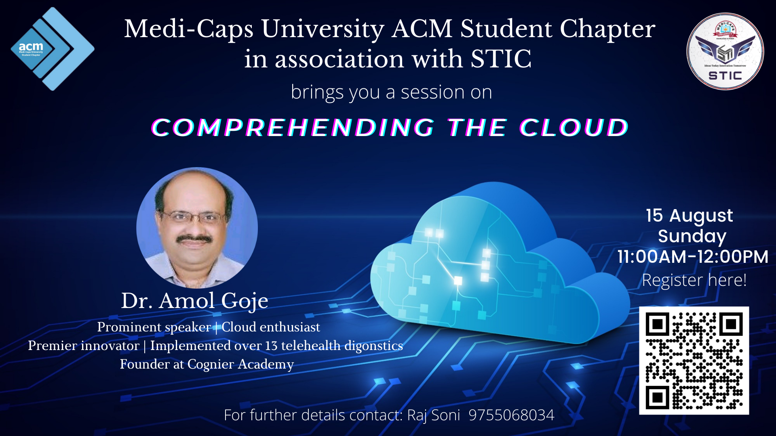

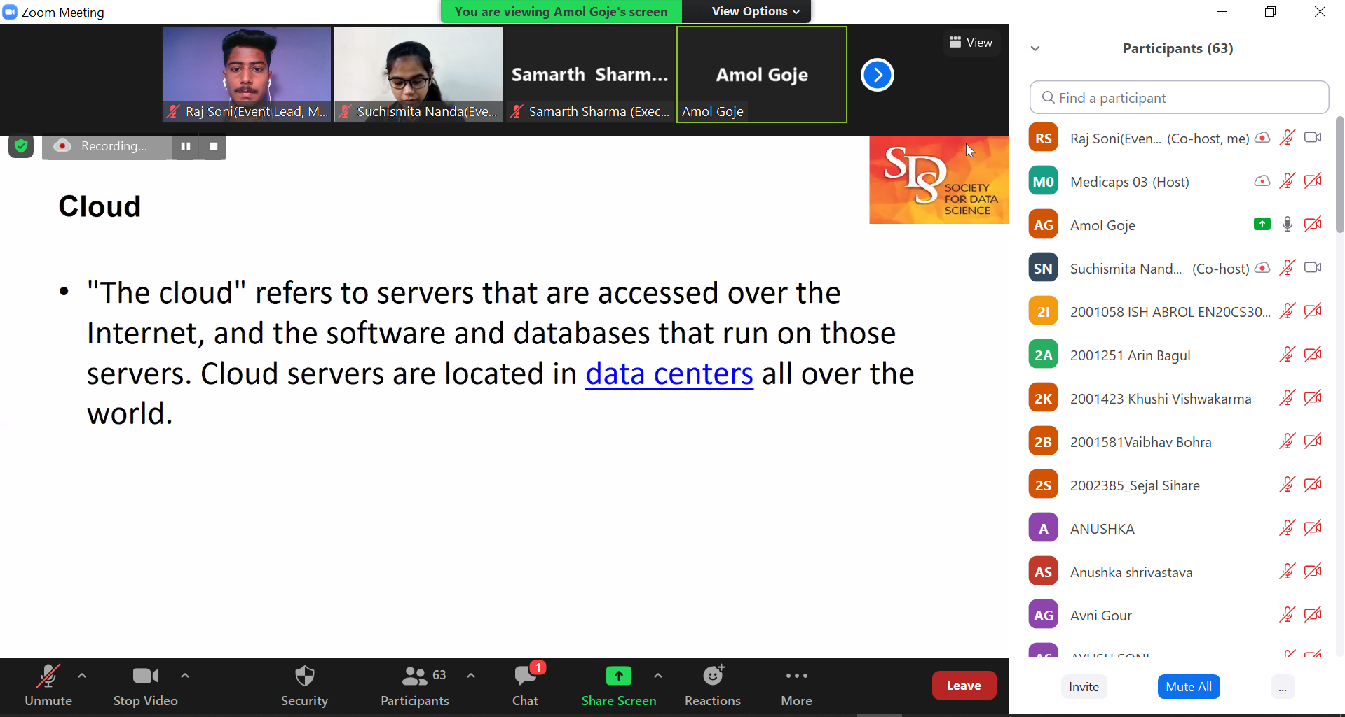

**List of Participants:**

[**https://docs.google.com/spreadsheets/d/1sJzXP5B1S6qN8nle8baCGX82K1aodGN4aSinulWTJgg/edit?usp=drivesdk**](https://docs.google.com/spreadsheets/d/1sJzXP5B1S6qN8nle8baCGX82K1aodGN4aSinulWTJgg/edit?usp=drivesdk)

**Signature of Convener / Organizing Faculty member.**